|  |  |
| --- | --- |
| CL1002  Programming Fundamentals Lab | Lab 01  Introduction to Programming Fundamentals |

# National University of Computer and Emerging Sciences

Fall 2024

# Aims and Objectives

# The aim of this lab is to equip students with the foundational knowledge and skills necessary to understand and apply fundamental programming concepts. The objectives of this lab are as follows.

# 1. Equip students with foundational knowledge of fundamental programming concepts. 2. Develop problem-solving skills through real-world examples. 3. Introduce students to the PAC (Problem Analysis Chart) methodology. 4. Familiarize students with IPO (Input-Process-Output) Charts. 5. Teach students how to create and interpret Flowcharts.

# Introduction

In this lab we will be covering the following topics

1. Problem solving in the context of programming fundamentals.
2. Introduction to Problem Analysis Charts.
3. Introduction to Input Process Output Table.
4. Introduction to flowcharts.

# Objective: 1 Problem Solving

What is Problem solving?

•**Definition**: Problem-solving in programming is identifying a problem, planning a solution, and executing that solution to achieve the desired result.

•**Importance**: It’s fundamental in programming because it helps create efficient, effective, and scalable solutions.

# Example

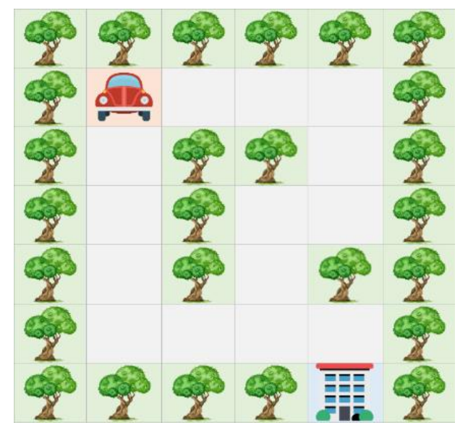Imagine that you have the following image, which is a map of a road leading to the building shown in the picture.

* There is a car and trees.
* The car cannot cross the trees
* The road is divided into squares to calculate the steps of the car.
* Each square is considered as one step.
* The car can be moved omni-directional.

How can the car arrive at the building?

Figure: 1(a) Problem solving

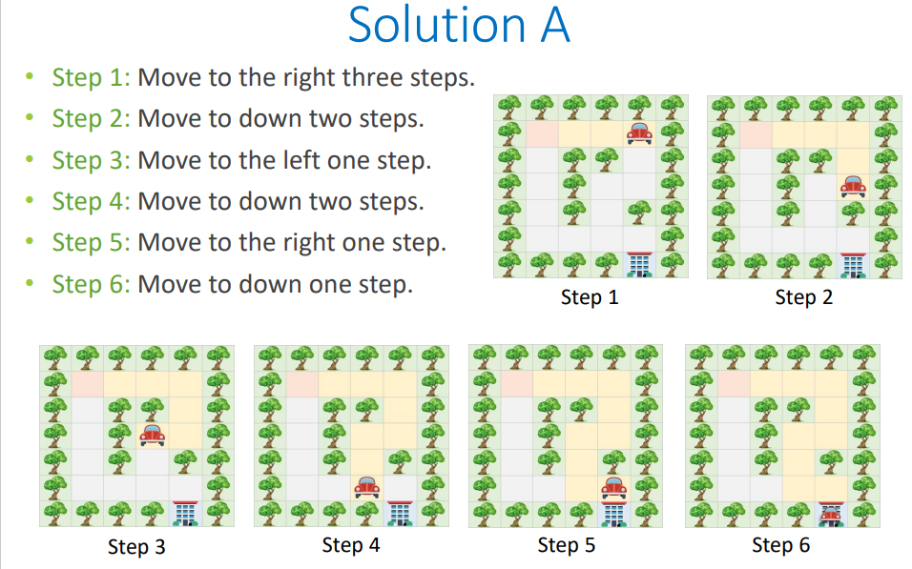

Figure: 1(b) Problem Solving

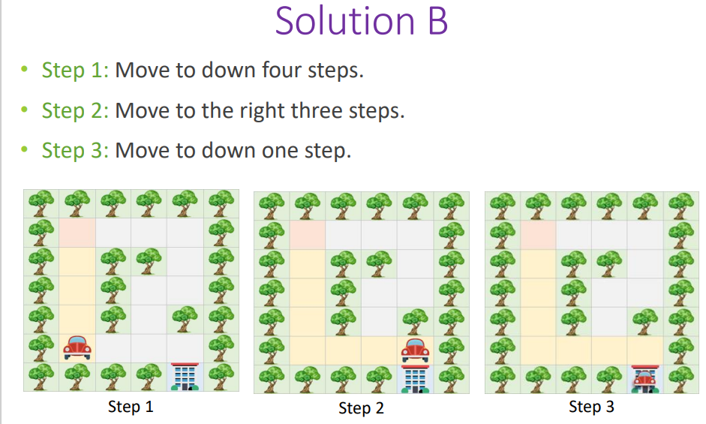

Figure: 1(c) Problem Solving

As we can see **Solution A** and **Solution B** are both correct solutions to the same problem, but there are differences in the complexity and efficiency of the solutions.

The cost of Solution A is 10 steps while Solution B is 8, so we consider Solution B a better solution based on the number of steps.

Reducing the number of steps in the previous example means reducing the fuel needed by the vehicle and speeding up the arrival time.

# Example 2

Consider yourself in a situation where you are a cashier (temporarily) at a department store. There are multiple denominations in the cash register with different quantities of them. Unfortunately, the cash register is broken, and it cannot determine how much cash is in the cash register. Your job is to efficiently figure out how much cash is in the cash register.

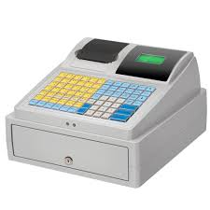

Figure: 2 Example of Cashier Register

Some more problems to solve 😁

* **Problem:** Consider the task of organizing a bookshelf. Which would be a better way of organizing the books in a bookshelf.
* **Problem:** You need to reach the university on time for an important exam, but there's heavy traffic on your usual route. The exam starts in 30 minutes, and it typically takes you 25 minutes to reach the university without traffic. Due to the current traffic conditions, taking your usual route could cause significant delays. Your goal is to determine an alternative route or mode of transportation to ensure you arrive on time
* **Problem:** You want to buy a new laptop that costs $500, but your monthly income is between $250-$300. However, you are currently spending a significant portion of your income on non-essential items, making it difficult to save enough money. Your goal is to develop a plan to budget your expenses so that you can save enough money to buy the laptop within a reasonable amount of time.

# Objective: 2 Problem Analysis Chart

The Problem Analysis Chart (PAC) is a dependent tool used in troubleshooting problems, especially in programming and systems development. It allows trouble to be broken down into smaller, more manageable parts and is often used to plan and document the steps needed to solve a problem using a programming language like C.

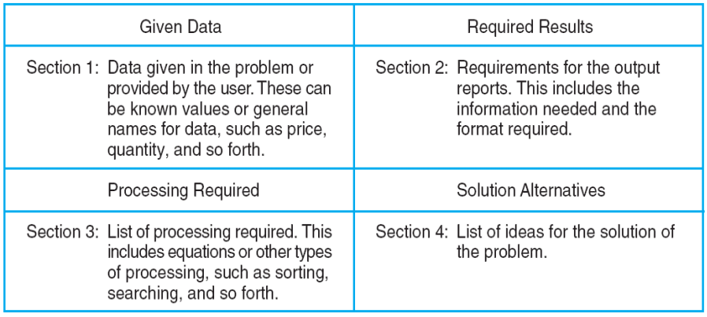

Figure: 3 An Example of a Problem Analysis Chart (PAC)

In a Problem Analysis Chart there are 4 sections that we need to concentrate on. The Top Left section is the data for the problem we are currently trying to solve, so it will include things such as variables, numerical data, percentile and more. The Top Right section is the desired output we require which is what the problem is based on. The bottom left section is the processing section where the necessary steps are enlisted to ensure the correct output for the required results, and the bottom right section are alternate solutions as a problem can have multiple solutions to achieve the same result.

# Example

We have a problem in which we want to calculate the gross pay of an employee at the department store that you were previously working as a cashier (assume you are the general manager of that department store). Since you studied well you remember the formula for calculating the formula for gross pay. But I will write it down anyway for ease of use.

**GrossPay = Hours*PayRate   
Payrate = 20$/HR**.  
**Hours = 12**

We need to develop a PAC chart for the above-mentioned problem.

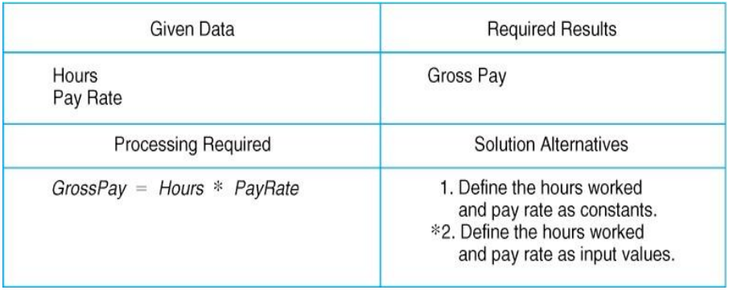

Figure: 4 Example of PAC chart

In the problem listed we identified that Hours and Pay Rate are the data that we are given so it is fed into the top left section of the chart. We require the gross pay of the employee so that goes to our required results section. A formula is required to calculate the gross pay so we can put it in the processing section, finally we can have multiple solutions to the problem as we can have an adaptive pay scale and hour scale.

Some more problems to solve 🥲

**Create PAC Charts of the following problems**

• Find the largest of three numbers entered by the user. The user will take 3 random values as input. (Note they can be constants)

•Calculate the sum of the digits of a given number.

•Find whether a given number is even or odd. Alternatively, the user would take two numbers as input, multiply them and then determine if it is an Odd or Even number

# Objective: 3 Input Process Output

The IPO (Input-Process-Output) model is used in programming and system design for several important reasons. It provides a clear, structured way to conceptualize and develop software by breaking down the process into three fundamental steps: Input, Process, and Output.

IPO Chart shows:

• What data item are input.

• What processing takes place on that data.

• What information will be the result, the output.

• Where in the solution the processing takes place.

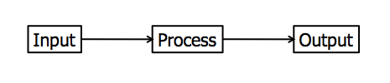

# Example

Figure: 5 An example IPO Chart of a Payroll System

In an IPO Chart we have 4 sections. Input, Processing, Module Reference and Output. Like the PAC chart we need to identify what are the input variables in our problem. The processing section has the same effect as the PAC chart but now in a more detailed layout where each step is enlisted. The Module Reference is one change from the PAC chart where each step of the processing section is converted into a command to which a computer will interpret. Such as Read, Calculate, Print, Loop, Write and Program control.

Some more problems to solve 🙁

* Find whether a given number is even or odd. Alternatively, the user would take two numbers as input, multiply them and then determine if it is an Odd or Even number (This is the same problem as the above mentioned just create an IPO Chart of it).

# Objective: 4 Flowcharts

Flow charts are diagrams showing the exact sequence of logical steps. They use geometrical shapes and arrows to show processes, relationships, and data/process flow. In other words, flowcharts depict decisions and results of them.

In different fields, flowcharts are often used to analyze and manage processes. To put it simply, it helps you visualize what the processes look like. That way, you can see all the bottlenecks and flaws in them. The act of creating a chart is called flowchart.

# Table: 1 basic flowchart

|  |  |
| --- | --- |
| Flowline symbol in flowchart of programming | **Flowline:** Indicates the flow of logic by connecting symbols. |
| Terminal symbol in flowchart of programming | **Terminals:** Represents the start and the end of a flowchart. |
| Input/Output symbol in flowchart of programming | **Input/Output:** Used for input & Output operation.   |  | | --- | |  | |
| Processing symbol in flowchart of programming | **Processing:** Used for arithmetic operations and data-manipulations. |

# Example

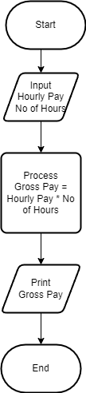

Figure: 6 Example of Flowchart

The start and End section of the Flow Chart represent the programs start and end boundaries. The Parallelogram where the Input and Print statements represent the Inputs and Outputs of the Program, and the Square Box represents the Processing required to achieve the desired output.

Some more problems to solve 😫

**Create Flow charts of the following problems**

Calculate the area of a rectangle given its length and width.

•Convert a temperature from Celsius to Fahrenheit.

•Calculate the average of three numbers.

References  
Introduction to problem solving   
<https://csu.kau.edu.sa/Files/612009/Files/160348_Chapter0_CPIT110_v2.pdf>

Programming Concepts  
<https://cs044.wordpress.com/wp-content/uploads/2017/02/chapter3-1.pdf>

Flowcharts  
<https://www.lucidchart.com/pages/what-is-a-flowchart-tutorial#:~:text=A%20flowchart%20is%20a%20diagram,easy%2Dto%2Dunderstand%20diagrams>.

Input-Process-Output Model  
<https://harpercollege.pressbooks.pub/programmingfundamentals/chapter/input-process-output-model/#:~:text=The%20input%E2%80%93process%E2%80%93output%20(,structure%20for%20describing%20a%20process>.

Problem Analysis Chart  
<https://www.studocu.com/row/document/inti-international-university/bahasa-kebangsaan/vbn-lecture-1-2-code/30284257>